TUTORING online tutorial 2 „How to plan a session“ – Mirjam Ilona Koerber

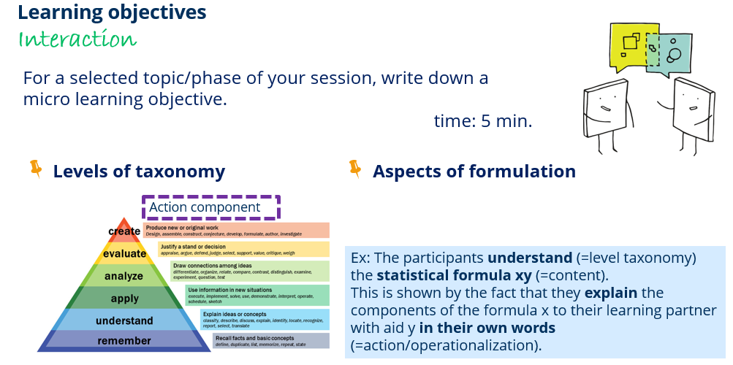

Tutorial: _______________________
Topic of the session: __________________

Content: __________________________________________________________________________
Action: ____________________________________________________________________________
Level of taxonomy: ________________________________________________________________

Micro goal: __________________________________________________________________________________
__________________________________________________________________________________

