

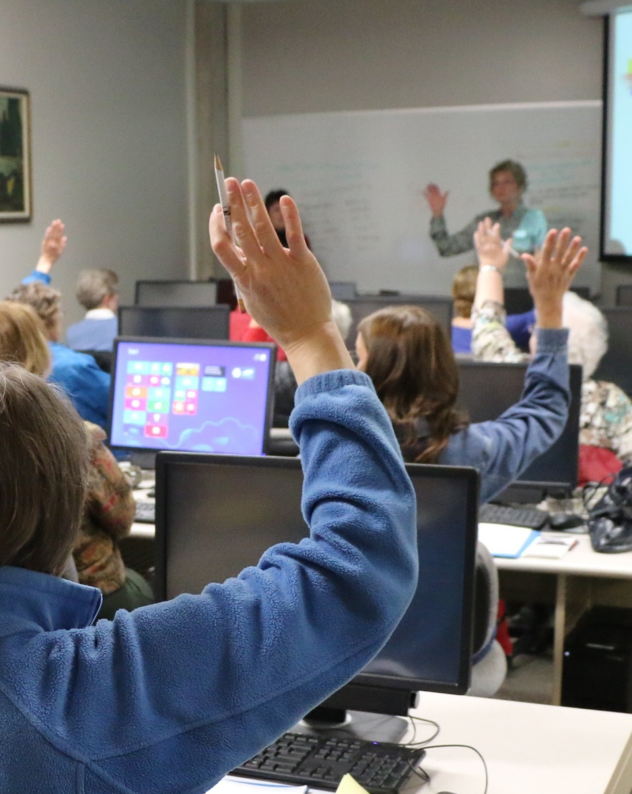
OER for teaching in higher education
Melanie Ludwig
TUTORING hybrid
Seminar room
preparation
A checklist
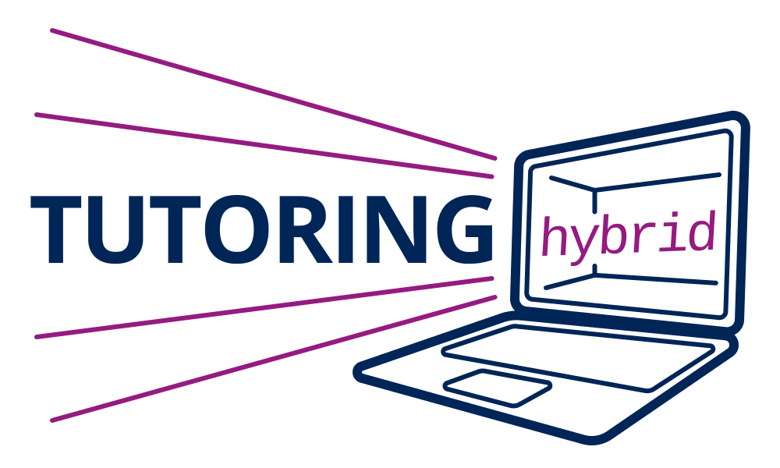
Foto: dschap | Pixabay

Checklist – Room preparation for seminars and tutorials
Room arrangement
- Are there enough chairs?
- What is the table arrangement?
- Is everything clean?
- Is the room ventilated?
- Can everyone see the presentation/pinboards?
- Is the pinboard/flipchart equipped with paper?
- Are the power cables secure?
- Are the pens all filled and writing well?
- Do the participants need documents?
- Light / sun / visibility of presentation possible?

Technology preparation
- Technology is connected
- Pointer has battery
- Laptop has sufficient battery or power
- Laptop is locked / PIN is there
- Zoom conference is open, turned down
- Cable to the projector is available
- Sound is working?

Personal preparation
- Presentation practiced several times
- Presentation on flash drive or printed out again?
- First words and sentences memorized?
- Own role has been clarified?
- Who keeps an eye on the time?
- Who will let online participants into the online room if necessary and can provide technical support in case of problems?
- Online tool is known and its use is clear (e.g. Zoom)
- Is sensitive data well protected?

Further ideas of your own:

Member of


Sponsored by


Contact
TU Dresden
Zentrum für interdisziplinäres
Lernen und Lehren (ZiLL)
PROJEKT TUTORING hybrid
01062 Dresden
🔗 tud.link/abcd
Imprint
Melanie Ludwig
Published under Creative Commons Attribution License (CC BY 4.0,
🔗 creativecommons.org/licenses/
by/4.0)




Accessibility:
QR code leading to the digital PDF version or the website with equivalent content

More information via the following link: 🔗 LINK

